SEG Awards Level 2

Motor Vehicle Studies

Underpinning Knowledge Evidence Record

T/601/6032 Knowledge of Inspection, Repair and Replacement of High Performance Light Vehicle Tyres

Learners Name
SEG Awards Registration Number
Centre Name
Assessor 1 Name
Assessor 2 Name

DECLARATION OF AUTHENTICITY

This declaration must be completed and signed by the learner and countersigned by the tutor / assessor and covers all evidence submitted for moderation.

Learner Name
Unique Learner Number (ULN) |  | SEG  Learner Reg. ID
Qualification Title
Centre Name

Learner statement of authenticity

Before signing please read the guidance below.

I confirm, that the attached assignment / portfolio is all my own work and does not include any work completed by anyone other than myself. I have completed the assignment / portfolio in accordance with SEG Awards’ instructions and within the time limits set by my centre.

Signature |  | Date

Centre confirmation of authenticity

On behalf of …………………………………….(insert centre name), I confirm that the above mentioned learner, to the best of my knowledge, is the sole author of the completed assignment / portfolio attached, and the assessments have been completed under the required conditions.

Signed |  | Date
Name
Title

Guidance for Learners

You have been asked to sign this Declaration of Authenticity and place it at the front of your portfolio or course work assessment. It confirms that the work you have submitted for assessment is your own and that you have not copied it from someone else or allowed another learner to copy it from you.

When preparing any course work it is good practice to undertake research using information from published sources. If you quote directly from these sources then this must be indicated in your work by using quotation marks and referencing the document from which the quotation was taken. You must then comment in your own words on any ideas expressed.

Assessors, internal verifiers and SEG Awards’ external moderators and verifiers are subject specialists who can spot the use of published materials that may be passed as your own words or ideas.
If you do copy words from a published source and do not indicate their reference you will be committing plagiarism. This is considered a form of cheating and may result in your assessment being declared void.

Contents

Task No | Title | Assessment Criteria
1 | Wheels and tyres | 1.1, 1.2, 1.3 ,1.4, 1.5
2 | Tools and equipment | 2.1, 2.2
3 | Repair materials | 3.1, 3.2
4 | Tyre markings, valve construction and faults | 4.1, 4.2, 4.3, 4.4, 4.5, 4.6, 4.7

Task 1 - Wheels and tyres | Assessment Criteria 1.1, 1.2, 1.3 ,1.4, 1.5

What is the main purpose of high performance light vehicle tyres?

Identify the labelled high performance light vehicle tyre components in the table below
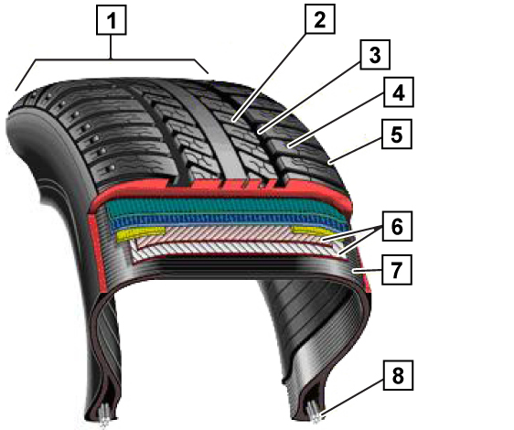 | 1
 | 2
 | 3
 | 4
 | 5
 | 6
 | 7
 | 8

Draw a diagram showing the construction and operation of the following 3 types of tyre and compare their differences
Directional tread | Compare the Construction and Operation
Asymmetric tread | Compare the Construction and Operation
Run flat tyres | Compare the Construction and Operation

Describe the construction and operation of the following 4 types of wheel and compare their differences
Steel | Describe the Construction and Operation and compare their differences
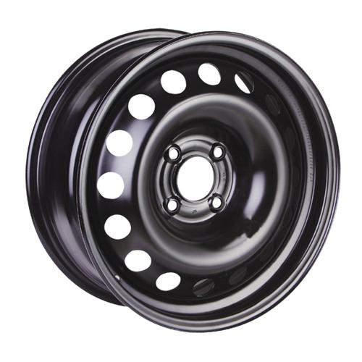
Alloy | Describe the Construction and Operation and compare their differences
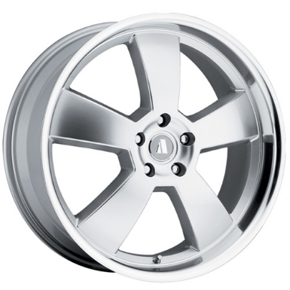
Wire | Describe the Construction and Operation and compare their differences
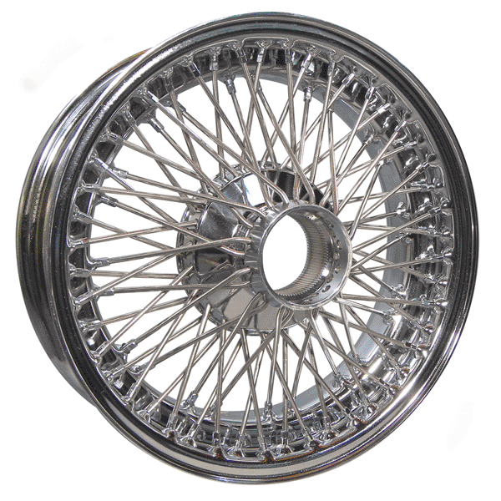
Split Rim | Describe the Construction and Operation and compare their differences
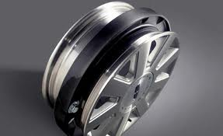

Tyre pressure monitoring | Describe the function and operation of the images
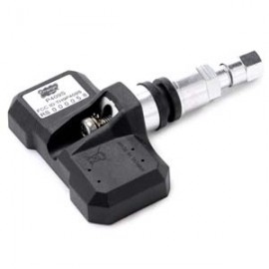
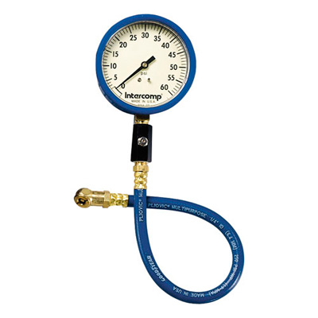
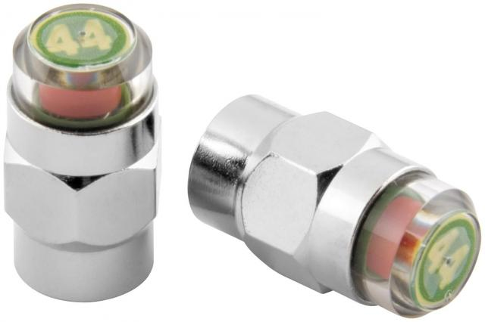

Explain the legal requirements for high performance light vehicle tyres
Legal requirement | Explanation

Explain the relevant parts of British and European Standard for the repair of high performance light vehicle tyres
Standard | Explanation

Give examples of how to deal with specialist waste in the workplace
Waste | Explanation

Task 2 - Tools and equipment | Assessment Criteria 2.1, 2.2

List tools and equipment used when working on high performance light vehicle tyres
Name of Tool / Equipment | Tool / Equipment safety checks | Explain how you would use the tool /Equipment safely

State the specialist maintenance requirements of high performance light vehicle tyre removal and refitting equipment
Name of Tool / Equipment | Tool / Equipment maintenance requirements | Time to next check

Task 3 - Repair materials | Assessment Criteria 3.1, 3.2

In the table below identify types of repair materials used for repairing damage to high performance light vehicle tyres, describing when these materials should be used.
Type of Repair Material | When to use the Repair Material

Task 4 - Tyre markings, valve construction and faults | Assessment Criteria 4.1, 4.2, 4.3, 4.4, 4.5, 4.6, 4.7

Valve Type | Describe their construction and how they are installed in the wheel
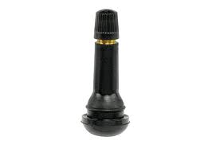
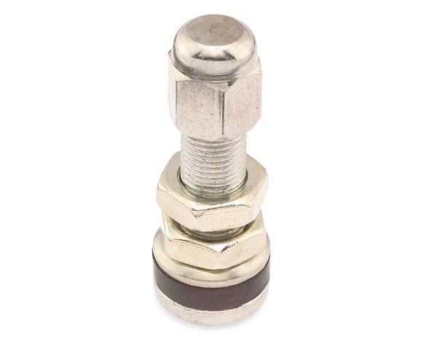

Identify the labelled tyre markings below and explain the meaning of each
 | Explanation of Markings
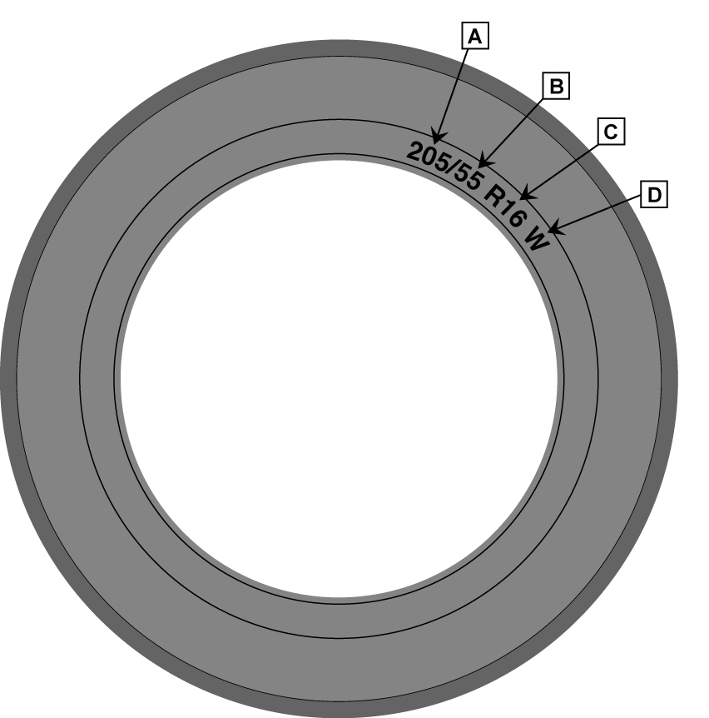 | A
 | B
 | C
 | D

Describe different inspection and fault identification methods, and procedures for repair on high performance tyres
Inspection Method | Fault Found | Repair procedure

Explain common faults and causes associated on high performance light vehicle wheels
Fault | Cause

Explain common faults and causes associated on high performance light vehicle tyres
Fault | Cause

Describe the standard methods and procedures for removing and re-fitting a high performance tyre

Explain how you would carry out the wheel balance procedures below and why you would use them
Static
Dynamic

Unless otherwise stated e.g. for some entry level qualifications, learners can work together but should identify sections which are their own work.

